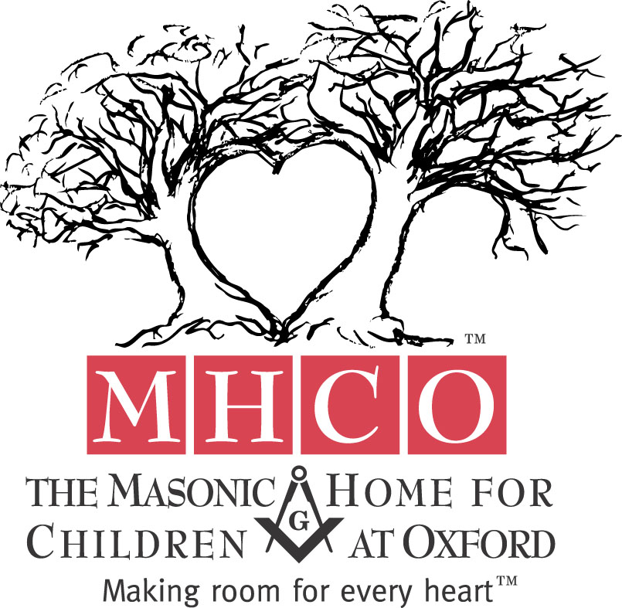
7/28/2026

From: Christopher Richardson
Director of Financial Development
The Masonic Home for Children at Oxford
For more information, call: Chris Richardson
At the Masonic Home for Children
(919)693-5111 or 1-888-505-4357
email – crichards@mhc-oxford.org

FOR IMMEDIATE RELEASE

MASONIC HOME TO HOST 119TH CAROLINA OPEN – STATE CHECKERS CHAMPIONSHIP
North Carolina’s Best Checker Players Compete Over Two Days for Top Prize

The North Carolina Checkers Association has chosen The Masonic Home for Children at Oxford to host their 119th State Open Checkers Tournament. The tournament will feature the best checker players from across the state and is an open format allowing those interested to sign up and compete. The tournament has not been held in the area for over thirty years. The two day event will be held Friday and Saturday, May 15th and 16th, 2009 from 8am to 5pm. Registration is open and will be held from 8:00am until 8:45am Friday, May 15th, 2009. The tournament will be held in the basement of the York Rite Chapel on the campus of The Masonic Home for Children. A special youth division tournament will be held for children 18 and under, Friday May 15th from 5pm to 9pm, with registration at 5pm. Trophies, certificates and cash prizes will be awarded in all classes on Saturday afternoon. For more information visit the North Carolina Checkers Association Website at www.nccheckers.org or call event organizer J.R. Smith at 336-209-5656.

